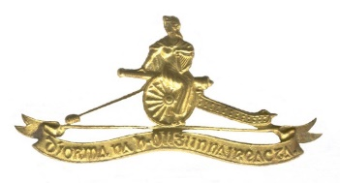
ARTILLERY CLUB’s DIARY of Events – 2026
(Changes since previous iteration highlighted in yellow)
Date | Event | Coordinator | Remarks
XX February | Committee Meeting: DFHQ Officers’ Mess McKee Barracks | Secretary
XX April | Committee Meeting: Mc Kee Barracks | Secretary
12 July | National Day of Commemoration | President
XX September | Annual Golf Competition & Dinner
XX September | Committee Meeting: DFHQ Officers’ Mess | Secretary
XX September | Defence Forces Veterans’ Day, McKee Barracks, Dublin
October | Foreign Field Trip
06 Nov | Units’ Annual Mass & Wreath Laying, McKee Barracks | Secretary
XX December | AGM and St Barbara’s Day Lunch, Auditorium and DFHQ Officers’ Mess, McKee Barracks | Secretary

