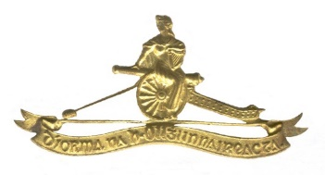**ARTILLERY CLUB’s DIARY of Events – 2025**

**(Changes since previous iteration highlighted in yellow)**

|  |  |  |  |
| --- | --- | --- | --- |
| **Date** | **Event** | **Coordinator** | **Remarks** |
| **24 February** | Committee Meeting: McKee Barracks | Secretary |  |
|  |  |  |  |
| **04 April** | Committee Meeting: Mc Kee Barracks | Secretary |  |
| **29 Apr - 01 May** | Field Trip: Spike Island and Cobh Heritage | Lt Col Brendan Crowley (Retd) | Calling Notice: 10 Mar |
|  |  |  |  |
| **17 July** | Committee Meeting: DFHQ Officers’ Mess | Secretary | Minutes Circulated |
| **13 July** | National Day of Commemoration | President |  |
|  |  |  |  |
| **04 September** | Annual Golf Competition & Dinner, Hedford Golf Club, Kells | Capt B Carey (Retd | Report on Website |
| **25 September** | Committee Meeting: DFHQ Officers’ Mess | Secretary |  |
|  |  |  |  |
| **28 September** | Defence Forces Veterans’ Day, McKee Barracks, Dublin |  |  |
| **07 – 11 October** | Foreign Field Trip: Malta | Comdt M. Flood (Retd) | Flights and Hotel Booked  Nominal Roll Circulated |
| **08 Nov (TBC)** | Units’ Annual Mass & Wreath Laying, McKee Barracks | Secretary |  |
| **05 or 12 December** | AGM and St Barbara’s Day Lunch | Secretary |  |