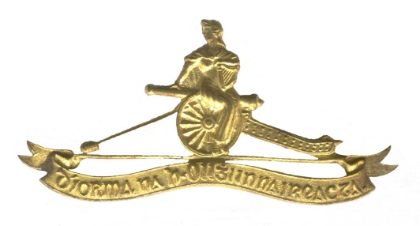

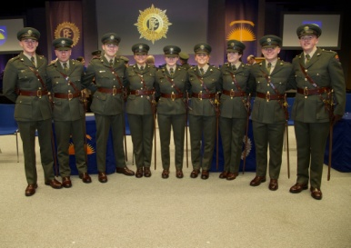
TAKE POST - THE ARTILLERY CLUB’s NEWSLETTER 1/2019
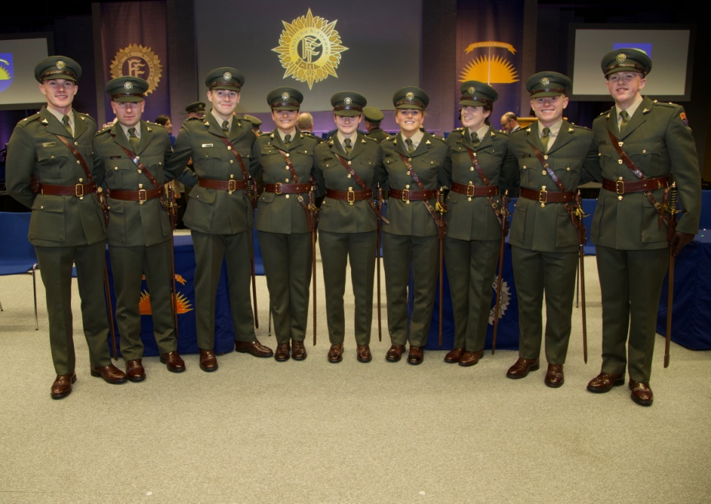
INTRODUCTION
Newsletter 4/2018 promulgated on 18 November, consisted of sections covering Governance, Activities, the Artillery Corps and Looking into the Past. The same format will be reflected in this Newsletter.
Since the publication of Newsletter 4/2018, through the medium of emails, members were provided specific details regarding activities such as the 2018 Annual General Meeting and St Barbara’s Lunch which took place on 07 December, Greetings for Saint Barbara’s Day, Christmas and the New Year, and the Field Trip to the Martello Tower in Killiney.
Particular issues within this Newsletter include 2018 AGM, Activity Reports, Planned Activities, and finally News from the Regiments. The article on Fort Dunree County Donegal and Garry Point Fort County Down was kindly provided by Colonel Brian O’Reilly (Retd). Photographs are credited to the Defence Forces Press Office and Club Membership.
Looking into the Past recalls the speech made by Canada’s Ambassador to Ireland,
H.E. Kevin Vickers ONB SC, Guest of Honour at the Club’s 2018 Annual Saint Barbara’s Lunch. The complete speech which was published in the Canadian Gunner News on
31 January, is posted on the Club’s Website in the Information Section under Publications.
The School Commandant and Regimental Commanders are requested to post this Newsletter on IKON, circulate it to all PDF and AR Artillery officers under their command, and are encouraged to provide information for subsequent Newsletters.
Likewise, serving and retired personnel are encouraged to provide information, news and photographs, for publication in the Club’s Newsletters.
Upcoming activities include the Visit to Áras and Uachtaráin and the Equitation School on Thursday 25 April, and the Field Trip to Cork Harbour Coast Defence Artillery Forts (1 & 8 Fd Arty Regts): 23/24 May. The current version of the Diary of Events for 2019 is posted on the Club’s website and is attached as Annex A.

GOVERNANCE
2018 Outputs
During 2018, in addition to governance matters, the Committee approved all Newsletters before promulgation, directed the Membership Drive, launched the Website, executed or participated in 20 activities, including the 90th Anniversary Gala Dinner, the Foreign Field Trip to Vienna, completed projects such as the elaboration of the Club’s Data Protection and Privacy Policy, the deployment, (on loan) of the Morris Commercial CDSW Quad 6x6 Gun Tower – ZC 5835 for the Curragh Military Museum, and advanced the Club’s Merchandise.
Focus for 2019
Mindful of the Club’s objectives as prescribed in the Rules, the focus remains on: executing appropriate activities, enhancing its Website, extending its Membership base and participating in appropriate ceremonial and commemorative events.
2019 Committee
During the course of the 2018 AGM, the following were elected as Officers, Committee Members and Auditor for 2019:
Appointment | Name
President | Brig Gen Paul Pakenham (Retd)
Immediate Past President | Comdt Chris O’Flanagan (Retd)
Secretary | Comdt Lar Joye
Treasurer | Col Tom O’Callaghan
Membership Secretary | Col Seamus McDermott (Retd)
Committee Member | Lt Col Cormac Lalor (Retd)
Committee Member | Comdt Michael Flood (Retd)
Committee Member | Comdt Richard Armstrong (Retd)
Committee Member | Capt Peter Murray (Retd)
Committee Member | Col Michael Smyth (Retd)
Auditor | Col Tom Carter (Retd)

The Committee co-opted Col Brian O’Connor (Retd), Col Conor Fitzsimons (Retd) and Comdt Derek Coulter (Retd) to its forum for 2019. The President will be inviting Regimental Commanders and the School Commandant to nominate a Liaison Officer to the Committee.
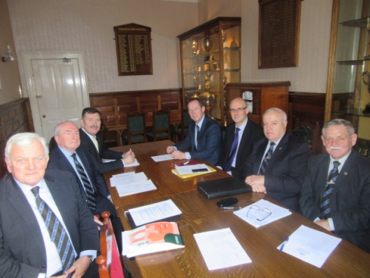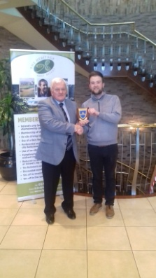
On 11 December, Col Tom Carter (Retd), on behalf of the Club, presented a plague to Mr Ger Dempsey, Manager of the Heritage Golf Resort, in recognition of the hospitality, support and very generous sponsorship of prizes for the 2018 Golf Outing.
Since the AGM, the Committee convened on two occasions: 24 January and 21 February. The Committee will reconvene on 25 April, 27 June and 26 September in McKee Barracks.
To-date, the Committee has developed the diary of events for 2019, conducted initial planning for the various activities, and successfully executed the Field Trip to the Killiney Mortello Tower on 21 February.
Communications
In addition to posting information on the Club’s Web site, the circulation of Newsletters, Activity Information, Calling Notices and Death Notices is primarily by means of email.
Newsletter 1/2015 was distributed by email to 122 individuals. The Club’s Email Contact List for this Newsletter is 290 individuals, far exceeding the Membership strength of 176. Currently, 15 members are receiving Club information by means of normal post.
Membership
Membership of the Artillery Club is open to all serving and retired commissioned Artillery officers of the Permanent Defence Force, An Fórsa Cosanta Áitiúil and the Army Reserve.
As of 21 February, the membership is 176, compared with 159 in October 2016, 129 in October 2015, and 96 in October 2014.
The President has invited the recently commissioned Gunner Officers to become members of the Artillery Club.
Potential members are requested to contact the Membership Secretary Colonel McDermott (Retd), Woodenbridge, Ballybrittas, Co Laois, or email: seamus.mcdermott@gmail.com.
Membership Subscriptions
Subscriptions for the current year were due on 01 November, 2018. To date, 107 of the 176 members have paid their subscription.
The preferred option of paying Membership Subscription (€10) is by Standing Order. The Committee is grateful to the 104 members who are currently paying their subscriptions by Standing Order.
Web Site
The Club’s Website is accessible through www.artilleryclub.ie. The Website provides a library of relative information on the Artillery Corps and the Artillery Club. The Website remains the primary communications instrument for the Artillery Club. Since the circulation of Newsletter 4/2018, the following postings were made on the Club’s Website:
- Posts – Homepage (4): Newsletter 4/2018, Calling Notice AGM, St Barbara’s Day Greetings, and ONE’s Sleeping Flags Appeal.
- Honorary Members – Membership Section (2): Lt Col Jim Dawson (Retd), and Comdt John O’Brian (Retd)
- News and Events (2): Newsletter 4/2018, Diary of Events 2019.
- Photo Gallery
  - Artillery Corps (2): St Barbara’s Day, (including Arty Sch, 2 Arty Regt and Presentations), and Commissioning on 04 February 2019.
  - Artillery Club (4): 2018 AGM, St Barbara’s Day Lunch, Election of Honorary Members, and Field Trip to Martello Tower No 7 .
- Publications – Information Section (1):
  - Artillery Corps: Canadian Ambassador’s Speech, St Barbara’s Day Lunch, 07 December 2018
  - Artillery Units:
  - Overseas:
Currently, the Picture Gallery contains 23 albums reflecting the Artillery Corps, and 34 Albums covering the activities of the Artillery Club.
Members are reminded that only a small portion of the web site requires text population including Artillery Corps Disposition and History, and Corps Units’ Disposition and History.
In due course, the procedures whereby the Club’s membership can be involved in the provision of material, including photographs, will be circulated. In the interim, observations on the Website will be welcomed.
Committee’s Short Term Priorities
The Club’s short term priorities are: visit to Áras an Uachtaráin and the Equitation School, Field Trip to Cork Harbour Coast Defence Locations (1 & 8 Fd Arty Regts), Artillery Wing – Curragh Military Museum, developing CONOPS for Athens, Membership (PDF and AR) and interface with other Corps Clubs.

ACTIVITIES
Diary of Events - 2019
The Club’s activities are of an Artillery nature, hopefully appealing to a large number of members. Members are encouraged to offer recommendations for Club activities. As already mentioned, the current version of the 2019 Diary of Events is posted on the Club’s website and attached as Annex A.
Acknowledgement
The Committee acknowledges the support provided by Mr Niall O’Donoghue owner of the Killiney Martello Tower for the Club’s first event in 2019.
Reports and Information
Reports on activities executed since the last Newsletter (4/2018), and initial information on future activities are outlined below.
Annual General Meeting & Saint Barbara’s Day Lunch – 07 December
With the kind permission of GOC 2 Brigade, the Club’s Annual General Meeting took on
07 December in McKee Barracks Dublin, followed by the Annual Saint Barbara’s Lunch in the DFHQ Officers’ Mess.
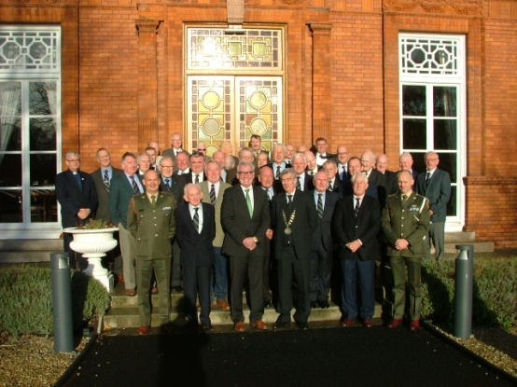
39 members attended the AGM and 21 apologies were received. The AGM approved reports from the President, Secretary, Treasurer and Membership Secretary. The attendees unanimously elected Lt Col Jim Dawson (Retd) and Comdt John O’Brian as Honorary Members. On behalf of the Director of Combat Support and ISTAR, Col Tom O’Callaghan provided a comprehensive brief on prevailing Artillery Corps issues. Draft minutes of the AGM, the financial accounts for the period ended 31 October, 2018 and the Power Point presentation slides, were circulated by email to members on 20 December.
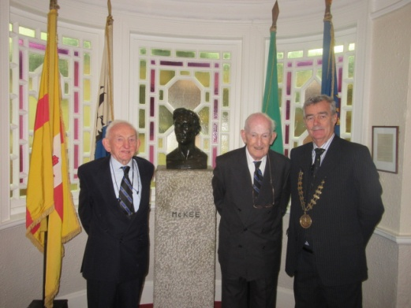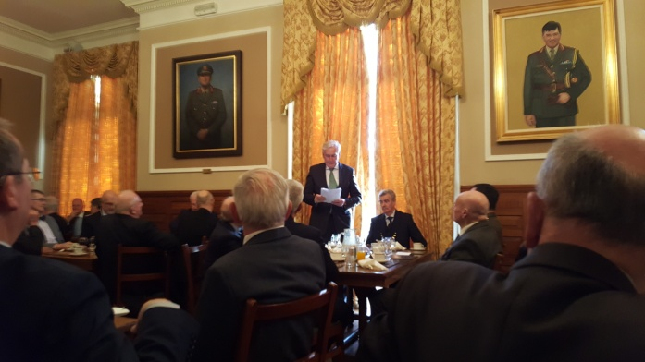
Following the AGM, members enjoyed the Annual St Barbara’s Lunch in the Officers’ Mess. H.E. Kevin Vickers ONB SC, Canadian Ambassador was the Guest of Honour. His speech can be viewed in the Club’s Website in the Information Section under Publications and, as previously stated, was published in the Canadian Gunner News on 31 January, 2019.
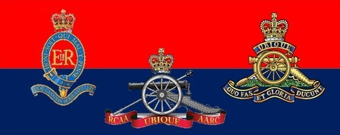
The Cavalry Club was represented at the dinner by Col Ray O’Lehan and Capt Damien O’Herlihy.
See Club’s Website for photographs of the AGM, Lunch and Honorary Membership.
The Committee will be seeking permission to hold the 2019 AGM and Saint Barbara’s Day Lunch in McKee Barracks, Dublin on Friday, 06 December.
Field Trip Dublin Dublin Defences: 21 February (Comdt Lar Joye)
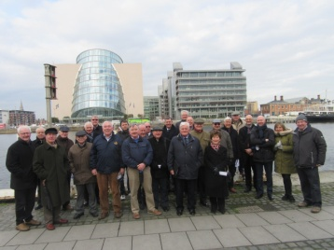
Comdt Lar Joye coordinated the successful and enjoyable Field Trip Dublin Defences, which was based in the Killiney Martello Tower, by kind permission of its owner Mr Niall O’Donoghue.
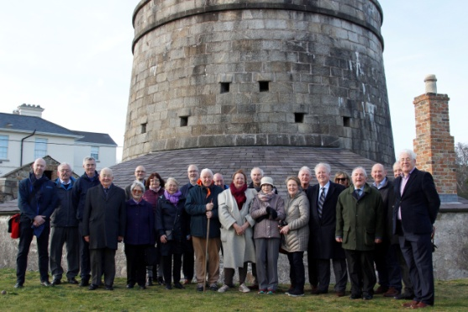
Martello Tower Number 7, on Tara Hill, Killiney Bay, is unique, as is its location as an enfilading tower. The Tower has been fully restored by its owner, to include a proofed, working King George 3rd Blomefield 18-pounder cannon mounted on a traversing carriage on the crown of the Tower. There is a three-gun battery below the tower, with a glacis. There is also a coach house, artillery store, tool shed, and gunner's cottage, with resident gunner and gunpowder store. No. 7 Tower was part of the defences of Killiney Bay against a possible French invasion in the period 1804 to 1815. The other towers and batteries have suffered a variety of fates, but this one was rescued and restored to its original glory and function by Niall O'Donoghue. For Video see: https://www.youtube.com/watch?v=OJ-v3AUw7n
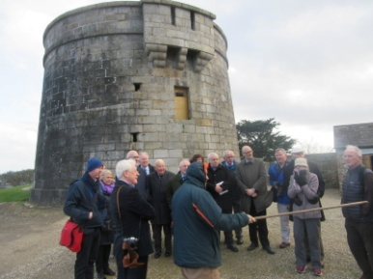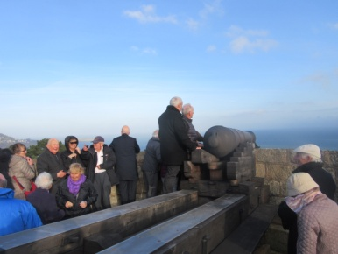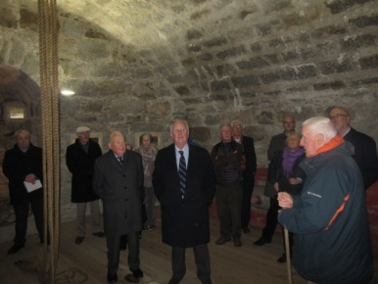
The comprehensive and informative tour of the Martello Tower was conducted by Mr Niall O’Donoghue, assisted by Mr Pól Ó Duibhir. Mr Pól Ó Duibhir’s article on the Martello Tower, which includes the restoration process, is published in the Autumn / Winter edition of the Dublin Historical Record, see:
https://photopol.com/martello/martello_dhr_winter_2017.pdf
On behalf of the attendees a Club Plague was presented to Mr Niall O’Donoghue by the Club President. See Club’s Website for event photographs.
Visit to Áras an Uachtaráin and Equitation School: 25 April (Col Conor Fitzsimons Retd). Programme: 1015 Coffee McKee Barracks, Depart for Áras at 1040, Tour, Lunch in the Officers’ Mess followed by visit to the Equitation School. Visit to Áras formally approved, max 30. Based on a quotation of €300, the Committee agreed to hire a civilian bus. Costings per individual: Bus €10, Lunch €30, total €40. Open to Members, Spouses and Partners. Calling Notice to follow.
Field Trip to Cork Harbour: 23/24 May (Lt Col Cormac Lalor Retd). Programme: Lunch Naval Base, Haulbowline, Hired Launch to Spike Island, Visit Spike Island, Group Dinner and Overnight in Carrigaline Court Hotel, Special Rate: €105 DBB Sharing, €135 Single Occupancy, Hotel Booking 021 4852100 – Code: Artillery Club, Visit to Camden Fort Meagher, Light Refreshments. Open to Members, Spouses and Partners. Calling Notice to follow.
Annual Golf Competition & Dinner: Woodenbridge, County Wicklow: 23 August (Comdt Chris O’Flanagan Retd & Comdt Michael Flood Retd). Annual Golf Outing takes place at the Woodenbridge Golf Club. Accommodation is arranged with the Woodenbridge Hotel. This recently refurbished 400 year old hotel is nested in the beautiful Vale of Avoca overlooking the golf course. Competition for the Capt Jack Jones Perpetual Trophy will be restricted to serving and retired Gunner Officers. Both the Golf Outing and Dinner are open to Members of the Artillery Club, their Spouses, Partners and Friends. Calling Notice to follow.
Arty Decades’ Reunion - Anniversary of PDF, FCA and AR Commissioning 1949-2019, 11 September (Col Mick Smyth Retd). This annual event, now in its forth year, envisages assembly in the Cadet’s Mess, Brief on the Cadet School and reunion lunch in the Officers’ Mess Pearse Barracks. Calling Notice to follow.
For planning purposes, Permanent Defence Force, An Fórsa Cosanta Áitiúil and the Army Reserve officers commissioned in 1949, 59, 69, 79, 89, 99, 2009 and 2019, are requested to contact the Club’s President (ppakenham@eircom.net) and the Event Coordinator (michaelsmyth007@gmail.com).
Calling Notice later.
Foreign Field Trip Athens: October 06 to 10 October (Comdt Michael Flood Retd). Hellenic Defence Staff has formally approved the visit. Currently, the dates for the Trip are 06 to 10 October. To facilitate travel arrangements, the selected dates will be promulgated, when they become available. The tentative programme includes an optional boat trip to the islands. Open to Members, Spouses and Partners. Coordinated Instructions will be circulated in due course.
ARTILLERY CORPS
St Barbara’s Day Events – 2 Artillery Regiment: 04 December
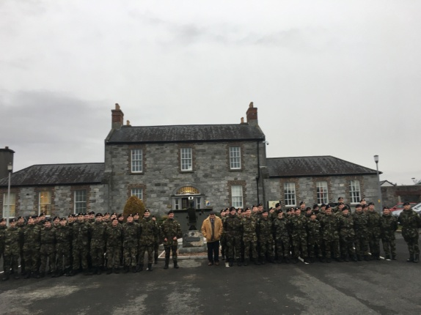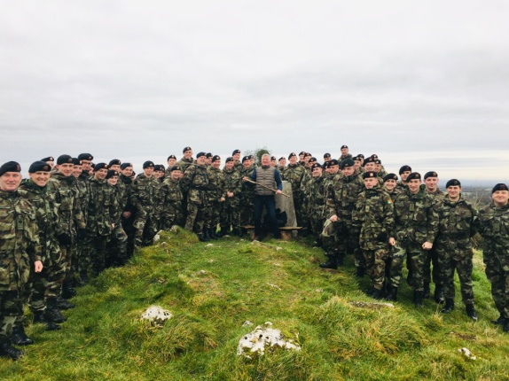
On St Barbara’s Day 2018, at a ceremony in Custume Barracks Athlone, the 2 Artillery Regiment unveiled a memorial plague honouring Gunners of All Ranks who Died in Service. The ceremony included a Minute Gun. Following a Gun Powder Breakfast, the Regiment went on a Field Trip to Mount Uisneach, and later made a presentation to Sergeant John Fitzgerald who was recently posted to J1 DFHQ.
St Barbara’s Day Events - Artillery School: 06 December
Due to the exigencies of the service, the Artillery School’s annual Prayer Service in honour of Saint Barbara, Patron Saint of the Artillery Corps and Gunners worldwide, took place this year on 06 December. The event was attended both serving and retired gunners of all ranks. Msgr John McDonald and Rev Fran Grasham conducted the Prayer Service at St Barbara’s Monument, followed by the firing of the Miniature Guns.
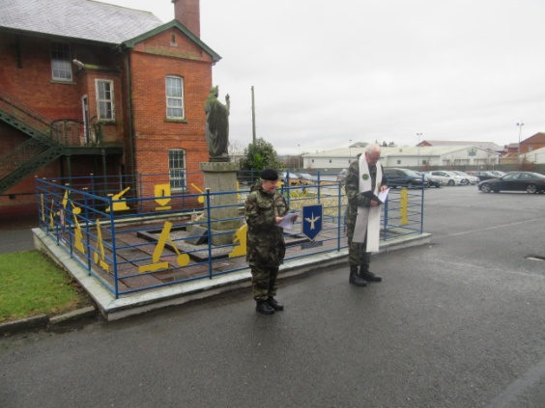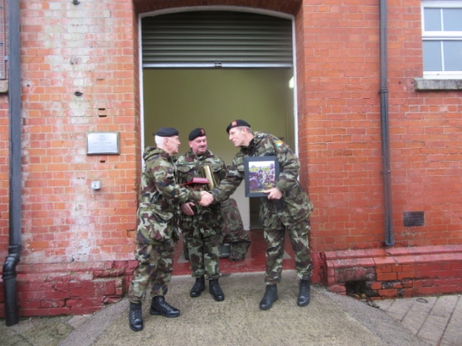
Following the Prayer Service, Lieutenant-Colonel Dermot Hanifin, School Commandant, The Artillery School, made a presentation to Brigadier-General Joe Mulligan, GOC Defence forces Training Centre, on his retirement from the Defence Forces.
Presentations were made in the Ceannt NCOs' Mess of items which will be on permanent display in the Artillery School, including the last flag flown in Magee Barracks on 23 September 1998, and a photograph of the 56 Inf Group UNDOF which was commanded by Lieutenant-Colonel Dermot Hanifin.
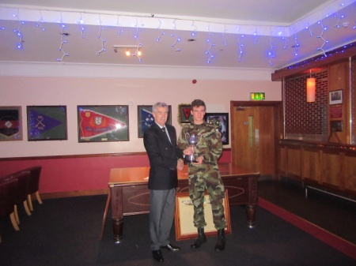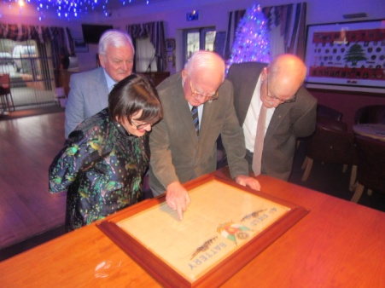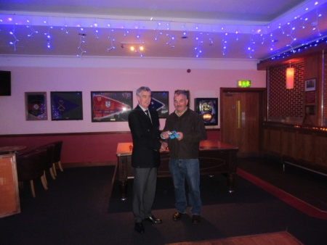
The President of the Artillery Club, Brigadier-General Paul Pakenham (Retd) received from Mrs Kathern Smyth the framed Organisation Chart of the 4 Field Artillery Battery 1939 - 1945, which was commanded by her father, Lieutenant-Colonel Denis Burke RIP. Colonel Seamus McDermott (Retd) supervised the project, and the Artillery Club remains grateful to Commandant Paul Walsh (Retd) for his technical and material support.
Brigadier-General Paul Pakenham (Retd) presented the Jack Jones Trophy to Lieutenant P.J. Dalton, Best Student on the 53 YO's Course. The Jack Jones Trophy Perpetual Trophy is an extension of an objective of the Artillery Club, which promotes professional excellence through sponsoring the Best Student Awards on Artillery Young Officers, Detachment Commanders and Regimental Survey Courses.
The Club President also presented a special gift to Regimental Sergeant-Major John Morris (Retd) on behalf of Brigadier-General Earnst Beno (Retd), Royal Canadian Artillery Regiment, in recognition of his support for the Regiment and in particular for facilitating the provision of 25pdrs to the Canadians for display in Normandy.
Promoted Regimental Sergeant-Major in June 1999, RSM John Morris was the first NCO to hold the rank of RSM in the Artillery School. With 18 years in the rank, RSM Morris has the longest service as an RSM in the history of the Artillery Corps. The Artillery Club wishes him health and happiness in his retirement.
See Club’s Website for event photographs.
54th Artillery Young Officers Course
The latest Young Officers Course commenced in the Artillery School on 11 February. There are 11 students on the course, including 10 officers of the 94 Cadet Class posted to the Artillery Corps on 04 February. The duration of the course is 25 weeks.
Commissioning Ceremony 94 Cadet Class: 04 February 2019
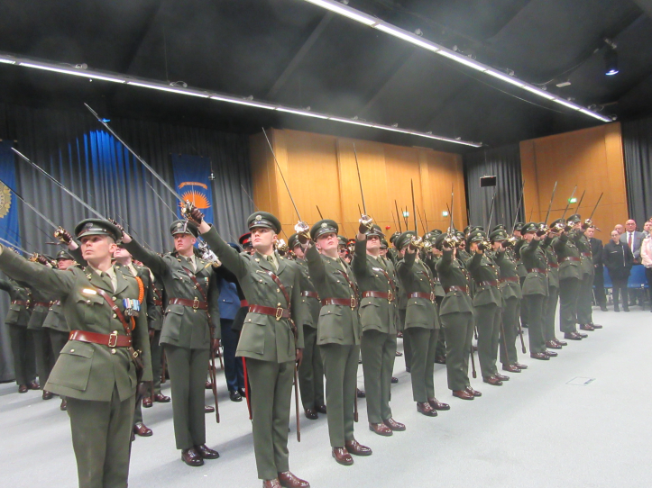
The Taoiseach Mr Leo Varadkar T.D and the Minister of State with special responsibility for Defence, Mr. Paul Kehoe T.D. accompanied by the Chief of Staff Vice-Admiral Mark Mellett DSM, attended the Commissioning Ceremony of 67 Army Officers, 1 Air Corps Officers and 9 Maltese Officers at Dublin Castle on Tuesday, 04 February 2019. This is the first time since the commissioning of the first Cadet Class (1928 – 1919) that the ceremony was held outside the Curragh Camp.
The newly appointed officers completed a demanding 15 months intensive training and have taken up appointments as junior leaders in Óglaigh na hÉireann and the Armed Forces of Malta. Commandant Stephan MacEoin was the Class Officer and Lieutenant-Colonel Gavin Young is the Cadet Master.
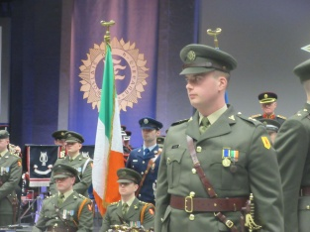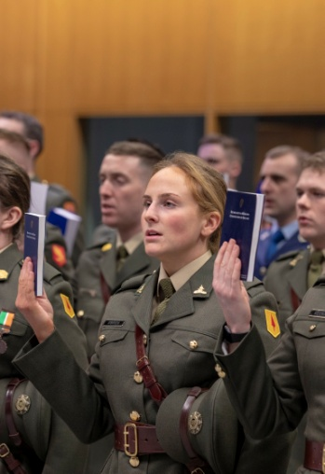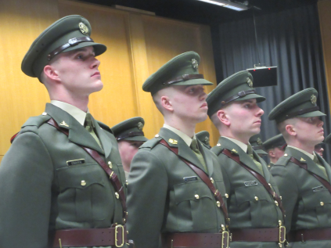
The Artillery Club extends sincere congratulations to the following ten officers who were commissioned in February 2019, and appointed by Vice-Admiral Mark Mellett DSM to the Artillery Corps:
1 Artillery Regiment
- Lt Joe Everett,
- Lt Niamh Ní Ghoill
- 2/Lt Louise Horgan
2 Artillery Regiment
- Lt Aifric Gallagher
- Lt Richard Wann
- 2/Lt Harry Dobson,
- 2/Lt Ruairi Ganley
- 2/Lt Liam O’Brian
- 2/Lt Meabh O’Brian
- 2/Lt Gavin Smyth
Likewise, the Artillery Club congratulates Lt Richard Wann, 2 Arty Regt, as the recipient of the Sergeant-Major Tony Scanlon Sword awarded to the Cadet who best promotes the Esprit de Corps of the Irish Defence Forces, its traditions and associations.
On 20 February, on the behalf of the Artillery Club, Brigadier-General Paul Pakenham wrote to all newly commissioned Gunner Officers, congratulating them on their appointment to the Artillery Corps, inviting them to become member of the Club and inviting them to the Decades’ Reunion on 11 September in The Military College.

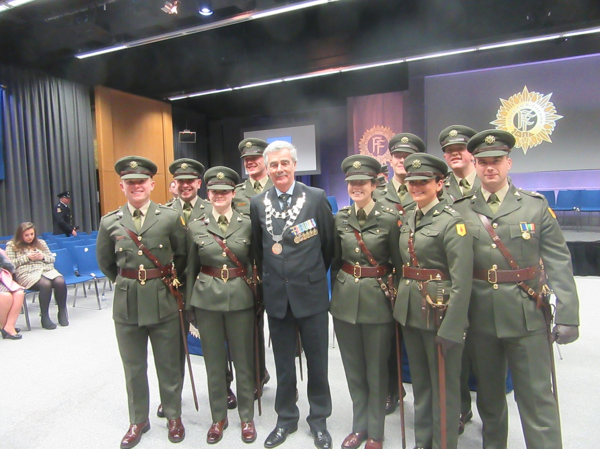
The newly commissioned Gunner Officers received their first salute from Regimental Sergeant-Major Mark Fitzsimons. However, 2 Lt Conor Marlow received his first salute from his father Regimental Sergeant-Major Andrew Marlow, 2 Artillery Regiment. Another proud father was Battery-Sergeant Gerry Setright, Artillery School, whose son Lt Jack Setright was also commissioned.
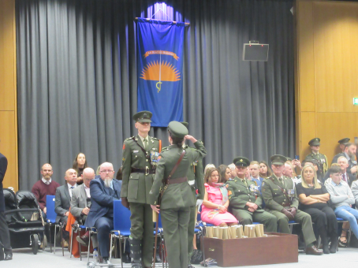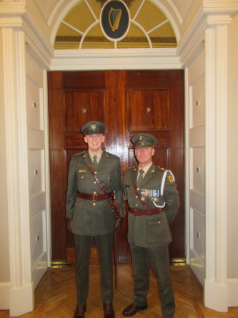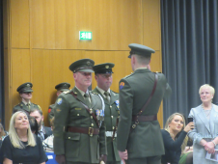
See Club’s Website for photographs of the commissioning

Fort Dunree County Donegal and Garry Point Fort County Down: Col Brian O’Reilly (Retd)
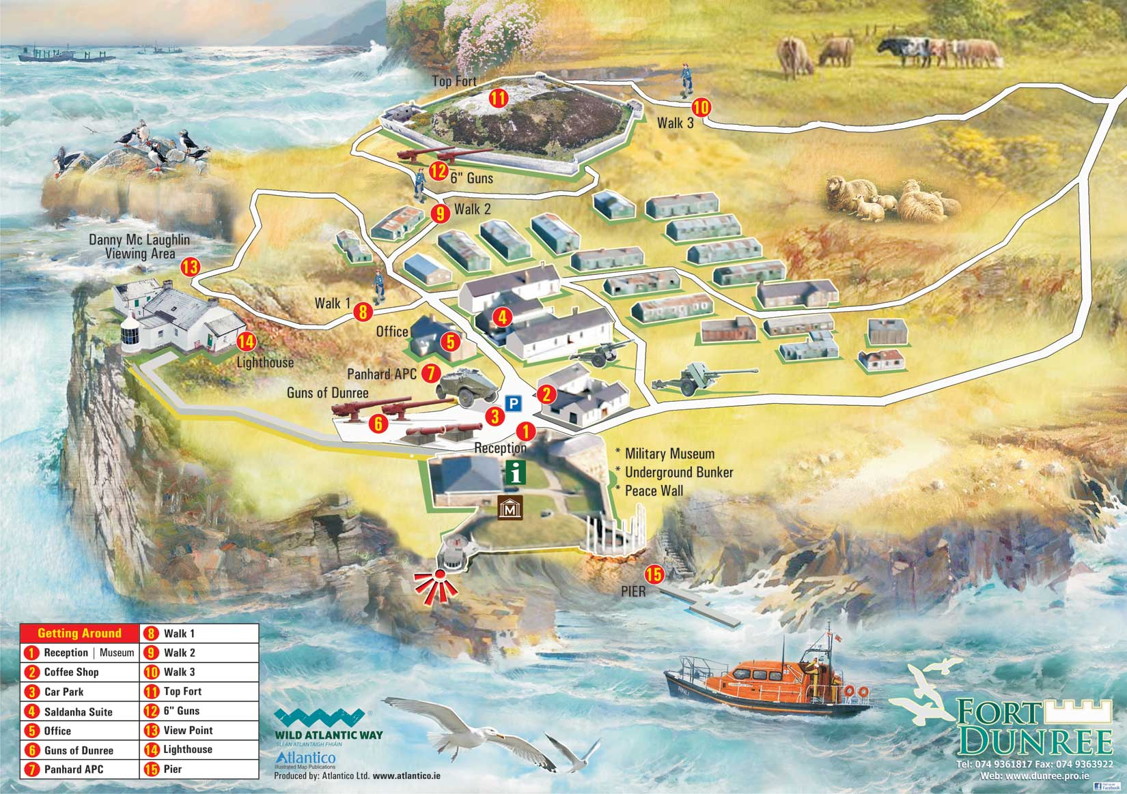
The Fort Dunree Heritage Museum complex was originally opened to the public in 1986, and over the subsequent years it has provided a fascinating and unique experience for visitors of all ages. It has also been a source of great pleasure and reminiscence for those of a military background, whether having served at the post or being involved in its military history.
Fort Dunree has an ongoing, collaborative relationship with the Department of Defence and the Defence Forces to preserve this very important national asset. In recent years this relationship has seen the range of artefacts on display augmented with new impressive artillery pieces, including a Panhard Armoured Personnel Carrier, handed over in a special ceremony by Chief of Staff, Lieutenant-General Conor O’Boyle DSM. Recently, Mr Paul Keogh TD Minister for State with Responsibility for Defence has agreed to the location of a refurbished L60 in Dunree. These artefacts are seen are a sign of confidence and appreciation of the work carried out by Fort Dunree Military Museum.
Located in Helens Bay, Belfast Lough, Grey Point Fort, equipped with a pair of 6inch guns that came from one of the Cork Forts, is owned by the Department of Environment Heritage Division and is open to the public. Since 2008, Grey Point Amateur Radio Society obtained permission to occupy Grey Point Fort and the constitutional aims of Grey Point Fort Amateur Radio Society is to restore Grey Point Fort as a living history museum and to research as much information as possible relating to Grey Point Fort during both World Wars.
In addition, to restoring Grey Point Fort, the members of Grey Point Fort Amateur Radio Society have created a unique WW2 Radio Museum consisting of over 100 radio communications equipment and other ancillaries located in the Command Post, and also WW1/WW2 Military Memorabilia Museum located in the magazine.
The Leader Cooperation Fund is an ideal vehicle from which Fort Dunree and Grey Point can both benefit. Meetings have taken place between Fort Dunree, Grey Point, Inishowen Development Partnership and North Down Borough Council. It was agreed that a project can be formed between these two strategically important assets. The first phase of this project, which will research the shared histories of the two forts, and will focus on the Soldiers who served in the two locations, both British and Irish, commenced in January 2019 and is expected to be completed by the end of April. We would welcome verbal or written contributions from any Gunners who served in Fort Dunree up to 1951.
The second phase will focus on the business plan and feasibility study for this project, and what is needed on both sites. The third phase would be the implementation of this plan and an upgrade in the exhibitions of both locations.
Obviously, there are a great number of synergies between these two historic sites. It is hoped that these similarities will be utilised to create a joint process that will benefit both projects and the communities that they form such an integral part of.
LOOKING INTO THE PAST
Canada’s Ambassador to Ireland, His Excellency Kevin Vickers ONB SC was Guest of Honour at the Club’s 2018 Annual Saint Barbara’s Dinner and was invited to toast Saint Barbara, the Patron Saint of Gunners. During the course of his speech, Ambassador stated, inter alia,
“I am honoured and exceptionally humbled to be invited to join you at this Annual Saint Barbara’s Dinner. I understand when gunpowder made its appearance in the Western world; Saint Barbara was invoked for aid against accidents resulting from explosions. Since some of the earlier artillery pieces often blew up instead of firing their projectile, Saint Barbara became the patroness of the artillerymen. She is also regarded as the patroness of armourers, gunsmiths and miners.
I was intrigued in learning of the origins of Ireland’s Artillery Corps through reading the history of the Battle of Ballinamuck. Shortly after arriving in Ireland, I read the Year of the French, 1798 so was well aware of the exploits of French General Humbert. From reading the book, I would say he was brilliant, especially choosing the route that he did from Kilcummin to Castlebar taking the English by total surprise. If only the other promised French reenforcements had arrived during the rising, perhaps the outcome would have been different. But I had not known of the persistence and bravery of Gunner James Magee during the Battle of Ballinamuck. And I have come to learn that Gunner James Magee is Ireland’s Artillery Corps’ figurehead. The 22nd of August, 1798 will be a day long remembered in Irish History. Certainly one of the most brilliant stories of that day refers to Gunner Magee, supported by his gun detachment, a small number of pike men, and a limited amount of ammunition. They made a final stand bearing a special courage and history given only to those men who long fought for the cause of freedom. The gallant stand in which these men made is well known among you. Never were men so brave, they ennobled the Cause of Ireland by their splendid gallantry on that very desperate occasion.
I have also learned of the very special relationship between Irish and Canadian Gunners. And as Ambassador of Canada and on behalf of all Canadians and Canadian Gunners, I would like to thank the Irish Artillery Corps for their extraordinary support. During the past six years the Irish Artillery Corps presented six 25 Pounder guns to The Royal Regiment of Canadian Artillery to help us remember and tell the story of the history and glorious past of Canadian Gunners. Thanks to our Irish friends, Canada has a 25 Pounder monument at Juno Beach in Normandy, France. There is another at Point 67 just south of Caen in Normandy to be dedicated after D-Day next year. A third gun is on display in the town Heerenberg, The Netherlands where the Canadian Army crossed the Rhine and began the final push north to liberate Holland in 1945. Three other 25 Pounder guns are in Toronto (Limber Gunners), Ontario, one in Montreal (3BAM) and the other in Lévis Quebec (6 RAC). I understand there are very active re-enactors who fire these guns on community and ceremonial occasions.
These six guns have helped the Canadian Artillery of today tell Canada and the world about the significant role that Canada’s Artillery has played in World Wars, peace support operations, counter-insurgency operations, peacekeeping and support to virtually all military operations everywhere – from early colonial times to Afghanistan, and even today.
Help in telling this story has been made possible through the support and generosity of the Irish Artillery Corps. Saint Barbara, the Patron Saint of Gunners has blessed the bonds of friendship between The Royal Regiment of Canadian Artillery and the Irish Artillery Corps. She is watching over our Gunner families. Our sharing of St Barbara as our patron saint is particularly symbolic in developing the bonds between the Artillery of Ireland and Canada. May such unity and collaboration continue well into the future. “

NEWSLETTER INFORMATION
Serving and retired personnel are encouraged to provide information, news and photographs, for publication in the Club’s Newsletters.

Once a Gunner – Always a Gunner
THE ARTILLERY CLUB
February 2019
Annex A: Diary of Events (V 25 Feb 19)

Annex A

ARTILLERY CLUB’s DIARY of Events – 2019
(Changes since previous iteration highlighted in yellow)
Date | Event | Coordinator | Remarks
24 January | Committee Meeting: McKee Barracks | Secretary | Minutes Circulated
21 February | Field Trip: Dublin Defences | Comdt Lar Joye | 27 Attendees, Photos on Website
21 February | Committee Meeting: McKee Barracks | Secretary | Minutes Circulated
25 April | Field Trip: Equitation School and Áras an Uachtaráin Archives | President
25 April | Committee Meeting: McKee Barracks | Secretary
11 May | Defence Forces Veterans’ Day: Collins Bks Dublin | Secretary
23/24 May | Field Trip: Cork Harbour Coast Defence Artillery Forts (1 & 8 Fd Arty Regts) | Lt Col C. Lalor (Retd)
27 June | Committee Meeting: McKee Barracks | Secretary
13 July | Commemoration - Islandbridge | President
14 July | National Day of Commemoration | President
July | Arty Shoot – Glen Imaal | Col S. McDermott (Retd)
August | Wreath Laying, National Memorial, Merrion Square | President
23 August | Annual Golf Competition & Dinner: Woodenbridge, Co Wicklow | Comdt C. O’Flanagan (Retd)
11 September | Arty Decades’ Reunion - Anniversary of PDF, FCA and AR Commissioning 1949-2019, Visit to Cadet School and Lunch in Military College | Col M. Smyth (Retd)
26 September | Committee Meeting: McKee Barracks | Secretary
06 – 10 Oct | Foreign Field Trip: Athens (Dates TBC) | Comdt M. Flood (Retd)
09 Nov | Wreath Laying & Annual Mass: McKee Barracks | Secretary
Nov | Arty Shoot – Glen Imaal | Col S. McDermott (Retd)
06 December | AGM and St Barbara’s Day Lunch: McKee Barracks | Secretary

